YEAR 10 SCIENCE (GENERAL)
PHYSICAL SCIENCES
REVISION - TEST 2

1. A dragster at Kwinana Motorplex uniformly accelerates from rest and covers the 400 m track in 7.101 s with a final speed of 309 km/h. Calculate the acceleration of the vehicle.

2. The highest "ridiculous" basketball shot is currently 201.4 m from the top of Maletsuyane Falls in Lesotho. Assuming the initial vertical velocity is zero when it is released and it takes 6.41 s to fall, how fast was the ball moving vertically when it reached the ring?

3. An ES-3A Shadow jet moving at 240 km/h relative to an aircraft carrier lands on its flight deck and the tail hook snags the arresting wire, which stops the jet in 2.30 s. Determine the deceleration experienced by the pilot.

4. In the Tour de France, a cyclist descending down the Col de Portet was moving at 110 km/h as he approached a sharp bend. He braked evenly and decelerated at 3.38 m/s² to make the turn at 40.0 km/h. How long did the rider brake?

5. The Shinkansen high-speed train in Japan decelerated at 2.0 m/s² for 35 s as it approached Kobe station and came to a stop. What was the speed of the train before it started braking?

6. Complete these statements about Newton’s three laws of motion.

(a) An object remains at rest, or will not change its speed or direction, unless ...

(b) When an unbalanced force acts on an object, the mass of an object affects ...

(c) For every action, there is ...

7. Complete the following table.

Force | Mass | Acceleration
100 N |  | 5 m/s²
 | 0.300 kg | 4 m/s²
1.2 N | 2 kg

8. Explain why the following statement is false.

A car travelling along a straight road has no forces acting on it.

Draw a diagram showing all of the forces acting on the car as part of your answer.

9. Explain in terms of Newton’s First Law of Motion and inertia why it is dangerous to have loose objects inside a moving car.

10. Use Newton’s Second Law and the equations of motion to calculate answers for the following.

(a) A 1400 kg car accelerates at 3.0 m/s². What size force is needed to cause this acceleration?

(b) A force of 160 N causes an object to accelerate at 2.0 m/s². What is the object’s mass?

(c) A force of 210 N acts on a mass of 70 kg moving at 5.0 m/s for 8.0 s. What is the final velocity of the mass?

11. A car is travelling down the highway at 90 km/h when a kangaroo bounces onto the road ahead. The driver takes 1.2 seconds to react and take his foot off the accelerator before braking hard.

(a) How far will the car travel during the time the driver is reacting? This is called the reaction distance. (Hint - this is constant speed.)

(b) The car’s brakes can slow the car at a rate of 6.0 m/s². How long will it take for the car to come to a complete stop?

(c) What force must be exerted by the brakes to stop the car if it has a mass of 1100 kg?

(d) The distance over which the car is brought to a stop by the brakes — the braking distance — is found using the equation:
where u is the speed at which the car was travelling when braking commenced and t is the period of time taken for the car to stop. Use the equation to determine the car’s braking distance.

(e) The total stopping distance of the car is equal to the reaction distance added to the braking distance. Calculate the stopping distance of the car.

12. (a) Explain the difference between mass and weight. Give an example to help your explanation.

(b) The acceleration due to gravity on Jupiter is 22.5 m/s². Calculate the weight of a
450 kg object on Jupiter.

13. Consider the forces acting on a body of mass 40 kg resting on a frictionless surface.

(a) Calculate the net force acting on the body.

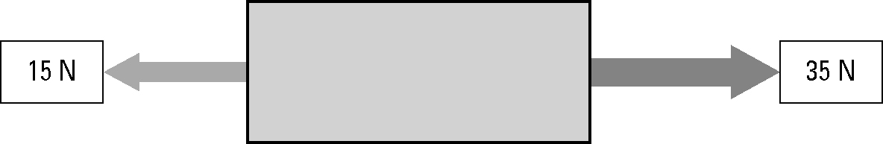

(b) Calculate the acceleration of the body.

14. What is the difference between a primary safety feature and a secondary safety feature?

15. By increasing the time over which a collision occurs, the force of the impact on a car and its passengers can be decreased.

List and describe at least two safety features of a car that decrease the force of impact in this way.

16. You studied a car safety feature as part of this topic.

(a) Name the safety feature and describe how it acts to protect passengers.

(b) State which of Newton's Law's applies to this safety feature and explain the Physics principles involved.

